# Your Name: ________________________________ Student Number: _______________________

# Lab 9a: to be done in class with a partner – due at the end of this lesson

Create a whole new class called Canada (i.e. do not use lab 8’s Canada class for lab 9). It consists of an array of size 13. Each element in the array is also an array: an array of three Strings:

1. The name of a province or territory
2. The name of the capital city of the province or territory
3. The name of the largest city by population of the province or territory

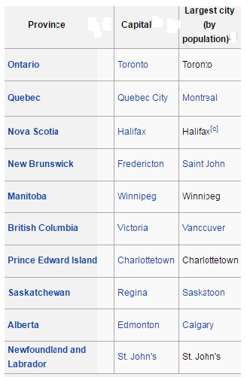

|  |  |  |  |
| --- | --- | --- | --- |
| Territory | Capital | Largest City (by population) |  |
| [Yukon](https://simple.wikipedia.org/wiki/Yukon) | [Whitehorse](https://simple.wikipedia.org/wiki/Whitehorse_Yukon_Territory) | [Whitehorse](https://simple.wikipedia.org/wiki/Whitehorse_Yukon_Territory) |  |
| [Nunavut](https://simple.wikipedia.org/wiki/Nunavut) | [Iqaluit](https://simple.wikipedia.org/wiki/Iqaluit,_Nunavut) | [Iqaluit](https://simple.wikipedia.org/wiki/Iqaluit,_Nunavut) |  |
| [Northwest Territories](https://simple.wikipedia.org/wiki/Northwest_Territories) | [Yellowknife](https://simple.wikipedia.org/wiki/Northwest_Territories) | [Yellowknife](https://simple.wikipedia.org/wiki/Northwest_Territories) |  |

Populate the array inside the Country constructor. The following code will be useful:

**public static final int BC = 0;**

**public static final int AB = 1;**

**etc...**

**public static final int NAME_OF_PROVINCE = 0;**

**public static final int NAME_OF_CAPITAL_CITY = 1;**

**public static final int NAME_OF_BIGGEST_CITY = 2;**

**provinces[BC][NAME_OF_PROVINCE] = “british Columbia”;**

**provinces[BC][NAME_OF_CAPITAL_CITY] = “victoria”;**

**provinces[BC][NAME_OF_BIGGEST_CITY] = “vancouver”;**

**provinces[AB][NAME_OF_PROVINCE] = “alberta”;**

**provinces[AB][NAME_OF_CAPITAL_CITY] = “edmonton”;**

**provinces[AB][NAME_OF_BIGGEST_CITY] = “calgary”;**

**etc...**

Create a method called **public String getCapitalCityOf(String province)** which returns the name of the capital city of the province (the parameter); if there is no such province, return null.

Create a method called **public String getLargestCityOf(String province)** which returns the name of the largest city of the province (the parameter); if there is no such province, return null.

Create a method called **public String getProvinceWhoseCapitalIs(String city)** which returns the name of the province whose capital city is the city (the parameter); if there is no such city, return null.

Create a method called **public void displayAllProvinceInfo()** which prints out all the data from the two-dimensional array in exactly the following format:

**The capital city of BRITISH COLUMBIA is Victoria, but the largest city is Vancouver.**

Or

**The capital city of NEWFOUNDLAND AND LABRADOR is St. John’s, and it is also the largest city.**

Demonstrate your completed project to your instructor. When your instructor is satisfied, your paper will be signed and you can go home. Lab 6b (below) is due at the next lesson, and there is also a quiz next day.

Checked by: ______________________________________

**NOTE:** keep this paper for your instructor to verify your grades later in the course.

**Note: there is no lab 9b.**

NOTE: EVERY SINGLE STUDENT MUST SUBMIT THIS LAB AND GET HIS OR HER PAPER SIGNED….